Utilization of Sealants and Medi-CAL utilization
- Preventive dental service utilization declined during COVID and has not fully returned to pre-pandemic levels
- Caries treatment utilization rebounded more quickly than preventive care, indicating continued reliance on reactive care
- Sealant use remains consistently low across all yrs and age groups, representing a major gap in preventive services
- Dental utilization is highest among younger children and declines with age, suggesting limited continuity care
- El Dorado County demonstrated moderate utilization relative to other counties, but follows the same pattern of underutilized prevention and higher treatment reliance

Oral Health Professional Supply and Non-Traumatic Dental Emergency Department Visits
The county demonstrates lower ED utilization for dental caries compared to the state, suggesting some level of effective preventative care. However, ED visits for more advanced dental conditions such as pulp and periapical tissue disease, and tooth loss remain substantial, indicating that individuals are still entering care at later, more severe stages. Despite having adequate workforce capacity, these patterns point to persistent barriers to timely and routine dental care, particularly among certain populations. This suggests that improving access and targeting high-risk communities may be more impactful than increasing provider supply alone.
(Since this dataset does not include a time variable, it should be interpreted as a recent baseline snapshot of oral health-related ED use and workforce capacity, rather than data from a specific year or period.)
Medi_Cal_Dental_FFS_Provider_Listing Locations in El Dorado
The distribution of Denti-Cal providers in El Dorado County is highly concentrated in areas such as El Dorado Hills and Placerville, with significantly fewer or zero providers in more rural communities. This uneven geographic distribution likely contributes to barriers in accessing routine and preventive dental care, particularly for the Medi-CAL populations. These access limitations help explain observed patterns of lower preventive service utilization, persistently low sealant use, and higher reliance on treatment services, indicating that care is often delayed until more severe conditions develop.
AskCHIS NE Data 2022
Modeled counts, not raw:
- 1 in 5 adults report fair or poor oral health, indicating a burden of untreated or advanced dental disease
- Over one-quarter of adults lack dental insurance, representing a major structural barrier to accessing routine and preventive care
- While nearly 88% of children report a dental visit in the past yr, preventive service utilization remains low
- Dental care utilization declines with age, and gaps in insurance and access contribute to worsening goral health outcomes in adulthood
CCWIP Data Load 5B Child Welfare Dental Visit Counts
Timely dental exam compliance among foster youth has remained below optimal levels across 2015-2025, with about 25%-45% of child-quarter observations not meeting timeliness requirements. Compliance declined during COVID and has partially recovered since then. This suggests ongoing challenges in maintaining consistent, timely access to dental care for a highly monitored and vulnerable population, highlighting broader system-level gaps in care coordination and preventive service delivery.
MIHA Dashboard
Around 800 respondents
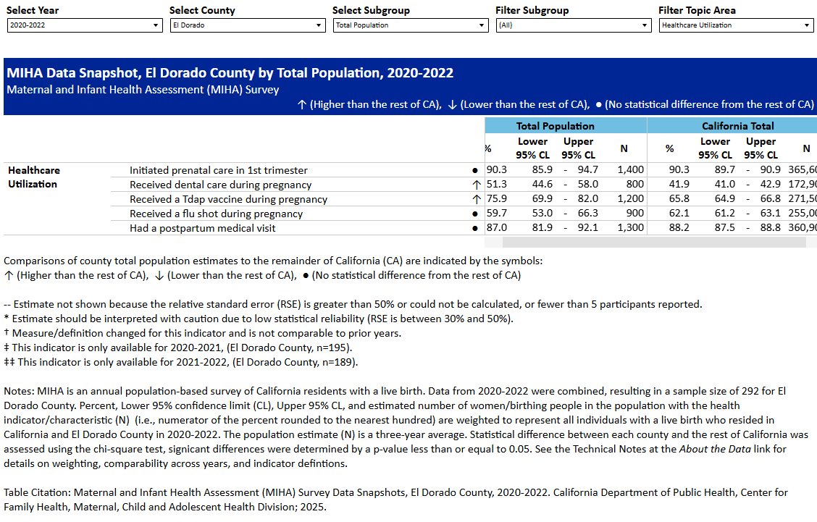
Dental Care during pregnancy: 51.3% (CI of 44.6% - 58%). The wider CI for El Dorado reflects smaller sample sizes and greater uncertainty, but the lack of overlap with the statewide estimates suggests that observed differences are likely meaningful. Our average is higher than the statewide average. This suggests that when individuals are actively engaged in the healthcare system, access to dental care improves. Our challenge is sustaining that connection beyond pregnancy.
California Cancer Registry (Oral Cavity and Pharynx)
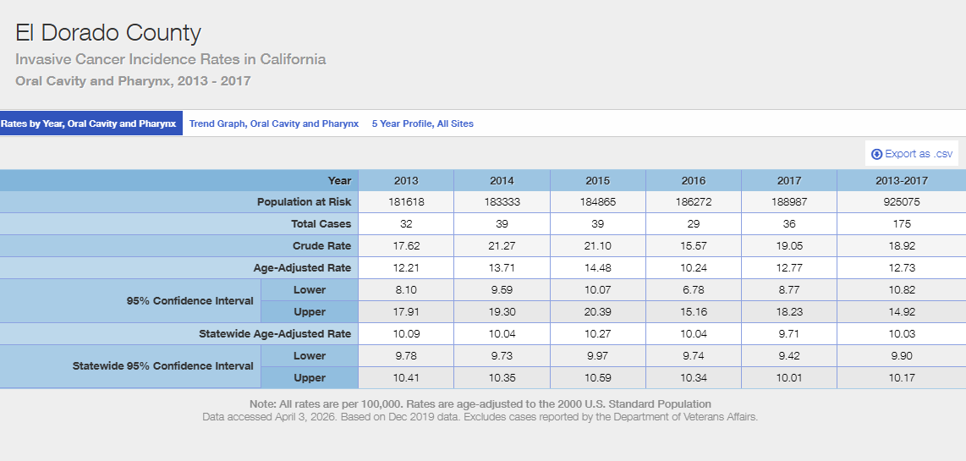
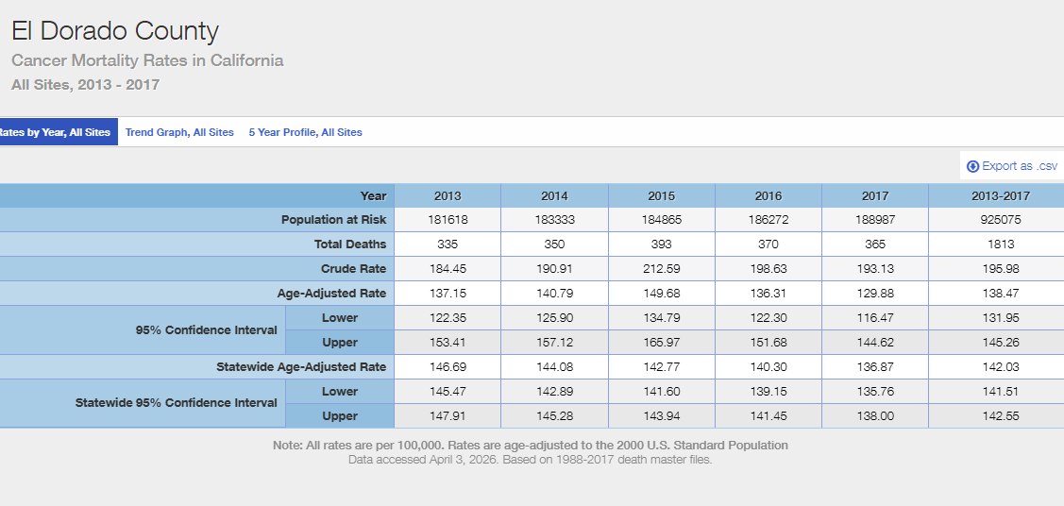
Patterns discussed previously are reflected in downstream outcomes, where the county experiences higher-than-state rates of oral cavity and pharyngeal cancer incidence and mortality. This suggests delayed detection and missed opportunities for early detection.
Well Dorado
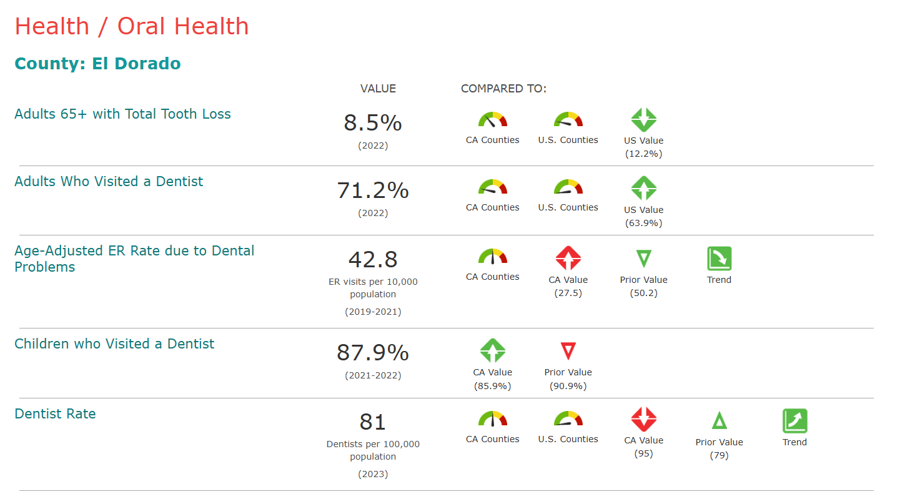
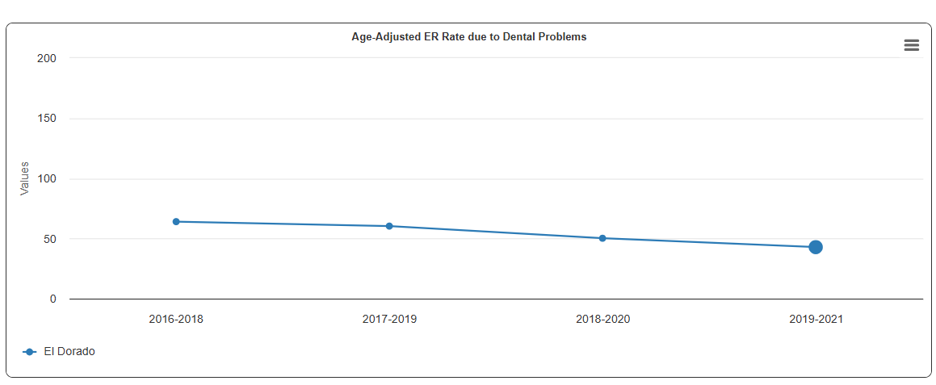
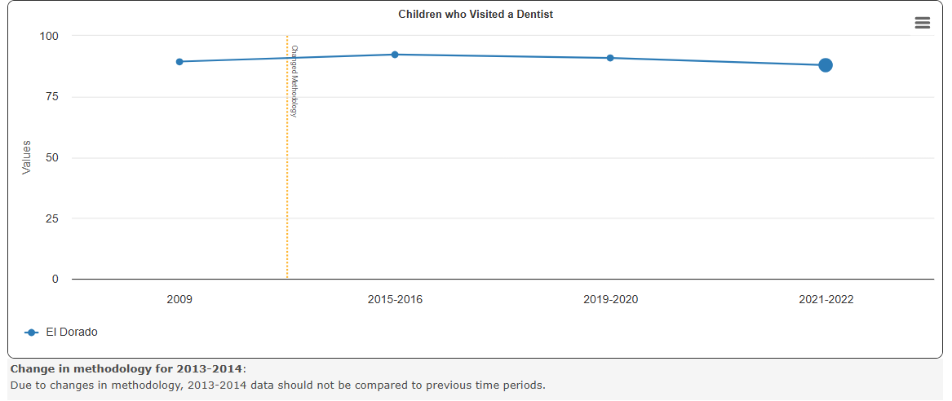
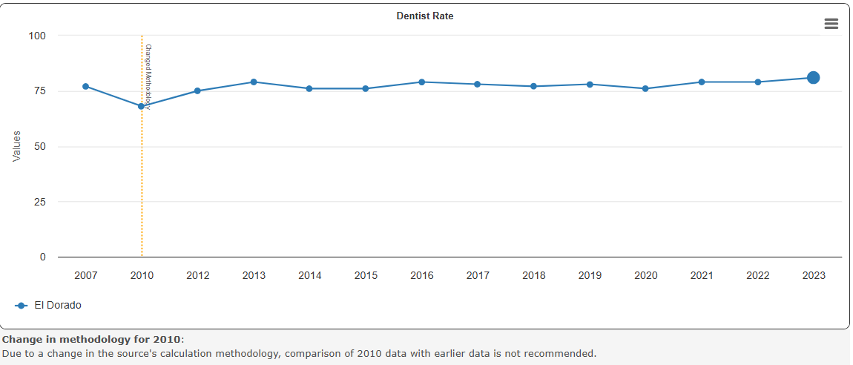
While dental visit rates are relatively high among both adults and children, the county experiences substantially higher rates of ED visits for dental conditions compared to the state, suggesting dental care may be episodic or delayed rather than preventive. Geographic disparities in provider distribution and gaps in dental insurance likely contribute to this pattern. These are reflected in downstream outcomes, like oral cancer incidence rates as previously mentioned.
Overall

recommended-guidelines-for-surveillance-of-ntdc-in-eds.pdf
ASTDD | Basic Screening Survey Tool
Oversampling with AskCHIS
Contact districts to tailor The California Healthy Kids Survey (CHKS) to include oral health questions. It is an anonymous, voluntary survey of school climate, safety, and overall student wellness. It is administered to students in grades five, seven, nine, and eleven on April of each yr.

